The Director,
Department of Skill Development,
Jammu and Kashmir.

No: KGP/Estt/2025-26/713-714 Dated:26-07-2025

Subject: Urgent Release of Funds to Clear Electricity Bill Liability.

Sir,

This is a follow-up to our letter dated 02-07-2025 (Ref: KGP/Estt/2025-26/5/510-512) regarding the outstanding electricity bill of approximately ₹20 lakhs owed to the Kashmir Power Distribution Corporation Limited (KPDCL).
We have been informed by KPDCL that failure to clear this outstanding amount within the next few days will result in the disconnection of the electricity service line to Kashmir Govt. Polytechnic College, Gogji Bagh, Srinagar. Such a disruption would severely impact the institution’s operations, affecting students, staff, and academic activities.
We urgently request your support in releasing the necessary funds at the earliest to settle the outstanding amount and ensure uninterrupted power supply for the smooth functioning of the institution. A copy of the bill from KPDCL is also enclosed for your reference.

Yours Faithfully
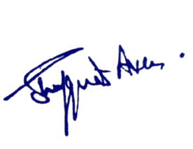
Enclosures:
1.Letter No:KGP/Estt/2025-26/5/510-512.
2.Copy of Electricity Bill.

Principal
Kashmir Government Polytechnic College
Srinagar

Copy to the:
1.Accounts Officer/Accountant, Department of Skill Development for Information.

